**Assignment # 3**

Due Date: April 10, 2020 till 11:59 pm (no further extension is possible)

**Title: What are different ‘Emerging Technologies’ prevailing in the market? How these technologies may bring ground-breaking changes in our life?**

**Guidelines:**

1. **First of all you need to explore and explain the concept of Emerging Technologies.**

Reference :<https://www.winston.com/en/legal-glossary/emerging-technology.html>

**Emerging technology** is a term generally used to describe a new technology, but it may also refer to the continuing development of an existing technology; it can have slightly different meaning when used in different areas, such as media, business, science, or education. The term commonly refers to technologies that are currently developing, or that are expected to be available within the next five to ten years, and is usually reserved for technologies that are creating, or are expected to create, significant social or economic effects.

1. **Second, you need to identify and explain different Types of Emerging Technologies.**

Reference :<https://www.techrepublic.com/article/the-5-emerging-technologies-worth-investing-in-for-2020/>

**The 5 emerging technologies worth investing in for 2020:**

## 1. Sensing and mobility

"Sensing and mobility sound like two very different things, but they are actually very closely related, in that it is sensing that is enabling mobility" Burke said.

Organizations considering sensing and mobility technologies should check their personal use cases to see if there is a need for 3D-sensing cameras, AR cloud, light-cargo delivery drones, flying autonomous vehicles, and autonomous driving—all of which are emerging under this trend, the report found.

## 2. Augmented human

Emerging technologies in the augmented human realm include biochips, personification, augmented intelligence, emotion AI, immersive workspaces, and biotech, the report found.

"When we talk about augmented humans we are talking about providing people with immersive experiences," said Burke. Whether this is through immersive workspaces, which allows you to work virtually from anywhere, or physical experiences like prosthetic limbs, he added.

## 3. Postclassical compute and communications

Classical core computing and communication technologies have been going on for the last 30 years, predicted under [Moore's Law](https://www.britannica.com/technology/Moores-law), Burke said.

However, "Post Classical communications and compute cover how the underlying technologies are being deployed in entirely different ways, which is really giving us a step-change in compute and communication power," Burke noted.

An example of this is low earth orbit (LEO) satellites, Burke added. "Satellites have completely changed how we are going to connect and commute globally, especially in underserved areas," he said.

Enterprises should consider postclassical compute and communications technologies if they have use cases for 5G, next-generation memory, LEO systems, and nanoscale 3D printing, according to the report.

## 4. Digital ecosystems

"We've had ecosystems since businesses started, but digital ecosystems are about how digital technologies are reducing friction in business ecosystems," Burke noted. On top of becoming more digital and reducing friction, he said, these ecosystems are also becoming more decentralized, which will allow users to have control over their own data and reduce the power of internet giants.

Examples of digital ecosystem technologies include DigitalOps, knowledge graphs, synthetic data, decentralized web, and decentralized autonomous organizations, the report found.

## 5. Advanced artificial intelligence (AI) and analytics

"AI is a pervasive trend," said Burke; it not only pervades the enterprise, but also all of these trends.

The most significant emerging uses of AI include adaptive machine learning, edge AI, edge analytics, explainable AI, AI platform as a service (PaaS), transfer learning, generative adversarial networks, and graph analytics, according to the report.

"We are seeing significant advances in AI algorithms, where AI is being used, and how AI is being democratized, so that it's not just strictly in the realm of giant tech companies, but are now available to end user organizations," Burke added.

1. Third, you need to explore and explain that how each type of Emerging Technology can help us in achieving innovative solutions to our problems.

Reference :<https://www.sshrc-crsh.gc.ca/society-societe/community-communite/ifca-iac/05-emerging_technologies_report-technologies_emergente_rapport-eng.aspx#theme02>

**Current open innovation approaches need to move away from “opening to,” and toward “collaborating with” multiple actors.**Today’s complex innovation challenges need open innovation approaches that focus on collaboration amongst multiple stakeholders. Currently, they tend to be focused on the organization’s needs, and how external actors and their ideas can help reach these goals. Organizations should adopt a more collaboration-centric vision that considers the values, visions and interests of all stakeholders, in order to ensure positive outcomes for all.

**Innovation is a social process that is influenced by both national and organizational culture.**The literature reviewed consistently identified certain cultural dimensions—such as individualism, low levels of family collectivism, and power distance—as occupying a clear role in supporting innovation. Ethnolinguistic and cultural diversity, taken together, were also found to support positive innovation outcomes, when diversity was well managed within organizations. This may be particularly relevant for Canada, given its diverse communities. National culture, meanwhile, can shape the practices of organizations, but these practices can and often do deviate from national cultural tendencies, especially in countries like Canada, where a wide range of behaviours are culturally accepted.

**Digital technologies have impacted how and where we work, and the production of knowledge more generally.**In the knowledge-based economy, workers are increasingly seeking more independence and flexibility from employers and hierarchical constraints. Growing steadily in popularity in recent years are “third places,” user-centric spaces outside the home and traditional workplace, such as living labs or fab labs. These spaces, usually made possible by digital technologies, foster collaboration, innovation and creativity, and have the potential to offer users a better balance between their work and their private lives.

**The integration of 3D printing into traditional manufacturing processes is still in its infancy.**Additive manufacturing only accounted for 1.9 per cent of industrial production in Canada in 2015. Despite its potential to reduce the manufacturing cycle and production time more generally, 3D printing is currently only a realistic option in small-to-medium-sized companies or small-scale, specialized industries, such as those in aeronautics or medical device manufacturing. Software complexity and extremely high costs are clear detractors when considering mass production of simple objects. As well, to build 3D skills, new, more collective pedagogical approaches are needed in the education system. The successful integration of 3D printing into the manufacturing cycle requires high levels of both technical and socio-organizational knowledge.

Reference :<https://www.mckinsey.com/industries/technology-media-and-telecommunications/our-insights/how-do-emerging-technologies-affect-the-creative-economy>

Research suggests some ways artificial intelligence, augmented reality, virtual reality, and blockchain are reshaping creative work.

### **DOWNLOADABLE RESOURCES**

*Open interactive popup*

1. [Article (PDF-4MB)](https://www.mckinsey.com/~/media/McKinsey/Industries/Technology%20Media%20and%20Telecommunications/Media%20and%20Entertainment/Our%20Insights/How%20do%20emerging%20technologies%20affect%20the%20creative%20economy/Creative-Disruption.ashx)

**New technologies are reshaping**the way we live and work, and their effects naturally touch the creative economy—art, journalism, music, and more. As artificial intelligence (AI), augmented reality, virtual reality (VR), and blockchain continue to emerge as powerful forces, could they be used to greater benefit?

Stay current on your favorite topics

[Subscribe](https://www.mckinsey.com/user-registration/register)

Our paper, Creative Disruption: The impact of emerging technologies on the creative economy, presents the findings of a joint project, conducted by McKinsey & Company and the World Economic Forum, which studied the impact of these technologies on the creative economy. The project team conducted more than 50 interviews with experts from Asia, Europe, and North America, as well as three workshops in China and the United States with World Economic Forum constituents. Given the varying maturity of the different technologies, it is too early to state definitively how they will change the creative economy. Instead, our paper outlines opportunities and concerns for each technology and presents suggestions for where attention could be concentrated. The rest of this article, extracted from the full report, summarizes some of our key findings.

## **Artificial intelligence is changing value chains for creative content**

Exciting developments using AI have been seen throughout the creative economy. Many take advantage of progress in machine learning to analyze huge data sets to learn specific behaviors, thereby allowing computers to recognize patterns and “learn” new actions without being explicitly programmed.

AI is helping creators to match content more effectively with audiences. Algorithms based on neural networks learn and classify a user’s preferences—from movies streamed on Netflix, music listened to on Spotify, or products purchased on Amazon. Providers can then recommend content tailored to a specific user.

AI aids production itself by performing tasks that are too difficult for humans. In advertising, it is used to contextualize social-media conversations to understand how consumers feel about products and to detect fraudulent ad impressions. Services such as Amper or Jukedeck compose music with AI, enabling small-scale creators to use high-quality music for their podcasts, videos, and games at low cost. Automated mastering software such as Landr provides near-studio-quality processing and rendering for between $50 and $300 a year.

Would you like to learn more about our [Media & Entertainment Practice](https://www.mckinsey.com/sitecore/service/notfound.aspx?item=web%3a%7bfe36c375-10b5-4d54-a554-88fc15fc3453%7d%40en)?

[Visit our Digital Media page](https://www.mckinsey.com/industries/technology-media-and-telecommunications/our-insights/how-do-emerging-technologies-affect-the-creative-economy)

In particular, AI that generates text is widespread in journalism and used by publishers to expand the range of offerings. [The Associated Press has used AI](https://digiday.com/media/washington-posts-robot-reporter-published-500-articles-last-year/) to free up around 20 percent of reporters’ time while increasing output tenfold. The Washington Post developed its own tool, Heliograf, to cover sports and political news. In its first year it generated about 70 articles a month, mostly stories it would not have dedicated staff to.

More disruptively, machine learning has begun to create original content. The implications have been felt across multiple industries. In music, [AI has produced instrumental sounds](https://www.wired.com/2017/05/google-uses-ai-create-1000s-new-musical-instruments/) that humans have never heard before. The same team taught a neural network to [draw sketches of animals and objects](https://experiments.withgoogle.com/ai/sketch-rnn-demo) and [generate sophisticated images from](https://research.googleblog.com/2015/06/inceptionism-going-deeper-into-neural.html) photography. In fashion, researchers have generated new designs. 1 And [in film, scripts have been written](https://www.mckinsey.com/industries/technology-media-and-telecommunications/our-insights/ai-in-storytelling), complete with stage instructions, for a science-fiction movie.

Other technologies have the potential to disrupt the value chain, though it will take time for the full implications to emerge. Notably, augmented and virtual reality offer an entirely new medium for creators to work with. Because this technology has the potential to become the “envelope” for all content, it is likely to redefine narrative conventions that have existed for decades. Other benefits are detailed in the full paper.

At the monetization phase, blockchain has the potential to [change the level of control artists have](https://www.mckinsey.com/industries/technology-media-and-telecommunications/our-insights/how-can-creative-industries-benefit-from-blockchain) over their work. The technology could allow artists to program their intellectual-property rights, revenues, and royalties into smart contracts that quickly and transparently allocate revenue to contributors. By removing the intermediaries between artist and consumer, blockchain may solve data and money issues in creative content—basing precisely how much to pay artists on actual consumption and [eliminating complexity in paying them](https://blog.mediachain.io/what-a-blockchain-for-music-really-means-e2f8dc66d57d). The technology could also affect production rights, third-party monetization, and data transfer of creative work, enabling the repurposing of creative content while safeguarding the intellectual property of artists.

## **Impressive technology is transforming creative experiences**

Content at the point of consumption is being dramatically altered by immersive technology. [According to one poll](https://www.ipsos.com/ipsos-mori/en-uk/virtual-reality-vr-whats-reality), 46 percent of audiences associate virtual reality with novel experiences and 60 percent with high-end gaming. But artificial and virtual reality have the capacity to provide truly transformative experiences by promoting new and meaningful feelings, skills, and understanding.

Immersive media could transform content as wide ranging as humanitarian stories and workplace-diversity training by providing users with situational perspectives that can help avoid stereotypes and false narratives.2 Other studies have detailed how experiences of content change when participants use different immersive devices. The right combination of story and device [could make content more effective](https://insights.ap.org/industry-trends/report-how-virtual-reality-will-impact-journalism) than it would be if presented through traditional media.

Many high-end immersive devices currently require high-spec stationary computers to power them, at a cost of several thousand dollars. With predictions of [VR headsets declining in price](https://www.tractica.com/research/virtual-reality-for-consumer-markets/) by about 15 percent each year and becoming untethered to PCs, it is conceivable that immersive technologies will become progressively more available to mass-market consumers. [According to one VR filmmaker](https://www.technologyreview.com/s/603468/imagining-the-future-of-vr-at-google/), this could herald a new way of remembering, not just creating. “Think of everything you forget about a birthday party when you’re a kid. [With widespread VR content capture], the rig would capture everything…. It is going to be interesting to see what happens when we aren’t able to forget anything anymore.”

However, this promise may be challenged if our dependence on mobile technology is replicated with AR and VR. Evidence from the past decade shows that while our overall leisure time is increasing, we are spending more of it using screen-based devices (Exhibit 1). Smartphone users interact with their devices an average of 85 times a day, 3 and 46 percent report [they could not live without them](http://www.pewinternet.org/2015/04/01/us-smartphone-use-in-2015/). Potential overuse leads to other concerns and might also affect the creative economy. [Studies have shown](https://papers.ssrn.com/sol3/papers.cfm?abstract_id=2439202) how off-screen performance is interrupted by digital devices, and recent research found that just the presence of a smartphone [can reduce cognitive capacity](https://www.journals.uchicago.edu/doi/10.1086/691462). Immersive devices, which could be at least as engaging as smartphones, may end up being inhibiting.

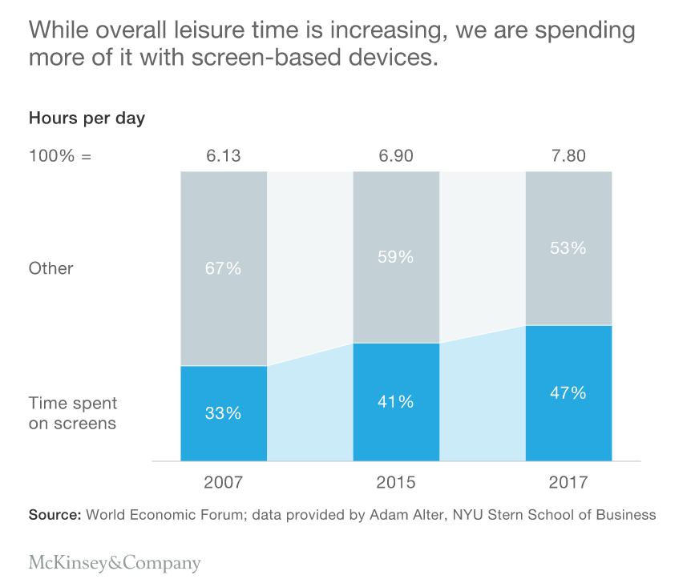

Exhibit 1

We strive to provide individuals with disabilities equal access to our website. If you would like information about this content we will be happy to work with you. Please email us at: [McKinsey_Website_Accessibility@mckinsey.com](mailto:McKinsey_Website_Accessibility@mckinsey.com)

The extent of the problem is starting to be acknowledged by social-media companies. Facebook has highlighted research showing how social media can affect well-being and [suggests that changing user habits](https://newsroom.fb.com/news/2017/12/hard-questions-is-spending-time-on-social-media-bad-for-us/) may help limit negative effects.

## **The creative economy and the platform economy are converging**

While these technologies have varying potential to change how content is produced and consumed, they are being applied in a dynamic environment. Publishers have used technology to find bigger audiences for their content but have less direct control over how that content is discovered. Instead, technology platforms are the main referral sources for digital publishers, with Facebook and Google responsible for [about 70 percent of online referral traffic](https://www.parse.ly/resources/data-studies/referrer-dashboard/) (Exhibit 2). This relationship is affecting both the editorial elements (what type of content is seen and why) and monetary elements (where the revenue accrues) of information and entertainment content.

Exhibit 2 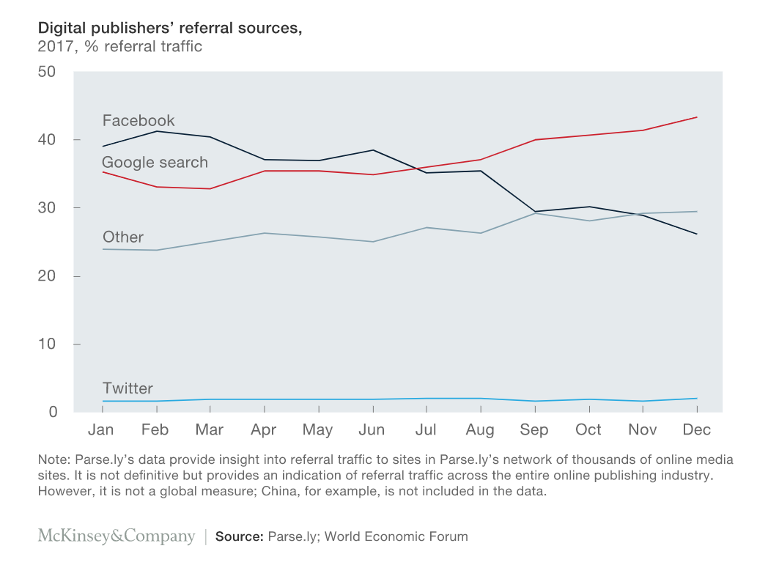

We strive to provide individuals with disabilities equal access to our website. If you would like information about this content we will be happy to work with you. Please email us at: [McKinsey_Website_Accessibility@mckinsey.com](mailto:McKinsey_Website_Accessibility@mckinsey.com)

On the editorial side, technology platforms can influence—intentionally or not—the types of content that flourish. Companies provide incentives, including money and advice, which sway publishers toward creating content that works well on their platforms. This is not always content with high artistic or civic values but, rather, content that is likely to spread quickly online.

Proprietary AI algorithms ensure that certain formats are prioritized in consumer searches and feeds. Facebook and Google, for example, have developed technology that reduces loading times for content, but the technology requires that content adhere to its standards. In doing so, the platforms exercise “explicitly editorial” judgments on content and design standards—decisions that used to be the province of traditional media. 4

The monetary benefits of this new relationship do not accrue entirely to content creators and publishers. Five companies take almost 80 percent of global mobile-advertising revenue, and [by some estimates](https://digitalcontentnext.org/blog/2016/06/16/google-and-facebook-devour-the-ad-and-data-pie-scraps-for-everyone-else/) almost 90 percent of the growth is going to just two companies, Facebook and Google (Exhibit 3).

Exhibit 3

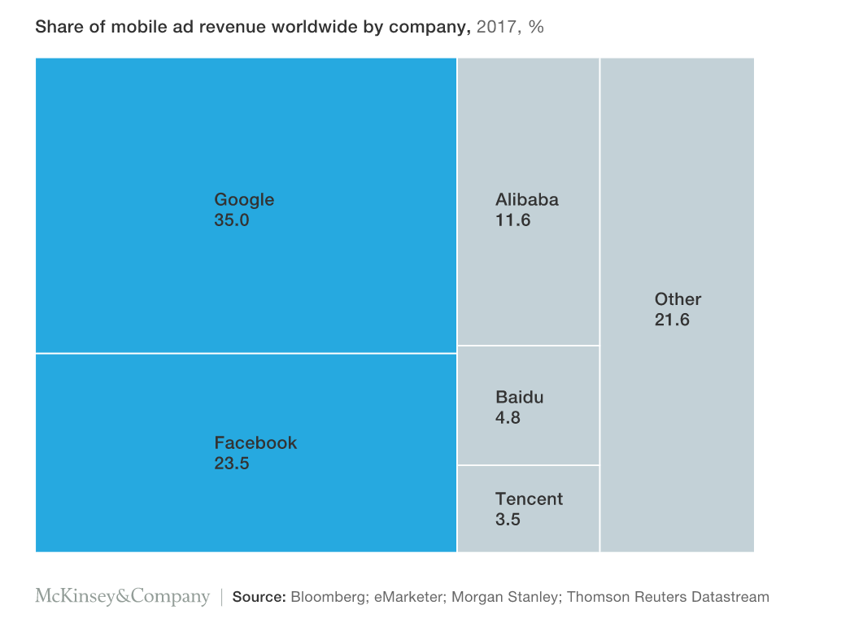

We strive to provide individuals with disabilities equal access to our website. If you would like information about this content we will be happy to work with you. Please email us at: [McKinsey_Website_Accessibility@mckinsey.com](mailto:McKinsey_Website_Accessibility@mckinsey.com)

It is uncertain whether this relationship between publishers and platforms will continue; [some adaptation is happening](https://digiday.com/media/please-subscription-hungry-publishers-google-ends-first-click-free-policy/). But the status is clearly changing, and in the process the responsibility for damaging content is moving away from publishers and toward other entities. One of the challenges of AI is that it lacks a conscious will and is unable to explain its output. Instead it must rely on the data it receives and the algorithms used. This may seem trivial in the context of machine-generated music or art. But when the technology can determine what editorial content appears in front of users, the ability to inform and shape public opinion grows, and the potential risks of opacity in decision making become bigger.

4. For report, you may use text (off course), and you are highly recommended to use images to support your text but with suitable references and citations both for text and images.

5. Uploaded this assignment in **CST 2234/ Activities/Assignment/ Upload Assignment # 3**. Moreover, you are also highly recommended to take assistance from books, academic websites and research papers.

6. Assignment with no references & citations will be getting zero mark. This is your last group assignment so please put highest possible efforts for best possible grade.

**Rubric for Evaluation:**

|  |  |  |  |  |  |  |
| --- | --- | --- | --- | --- | --- | --- |
| **Task +-** | **90% - 100 % (+&-)** | **80 %-89 % (+&-)** | **70 % - 79 % (+&-)** | **60 %- 69 % (+&-)** | **50% - 59% (+&-)** | **0 %- 49%** |
| **Relevant Theory and Diagram** | Fully covers the concepts, contents (as far as theory and diagrams are concerned) | Close to full coverage of the concepts, contents (as far as theory and diagrams are concerned) | Partial coverage of the concepts, contents (as far as theory and diagrams are concerned) | Half coverage of the concepts, contents (as far as theory and diagrams are concerned) | Very little coverage of the concepts, contents (as far as theory and diagrams are concerned) | Failed to understand the concepts given in the examination |

**Note:**  (+ & -) means that the grade may fall in sub-grades accordingly.